

# OF PITCHES:

BULLPEN PERFORMANCE CHART

DATE:

PITCHER:

1=FB 2=CB 3=SL 4=CH 5=Other

STRIKE BALL TOTAL %

|  |  |  |  |  |
| --- | --- | --- | --- | --- |
| FB |  |  |  |  |
| SL |  |  |  |  |
| CB |  |  |  |  |
| CH |  |  |  |  |
| OTH |  |  |  |  |
|  |  |  |  |  |
| TOTAL |  |  |  |  |

OUT OF STRIKE ZONE

EDGE OF STRIKE ZONE

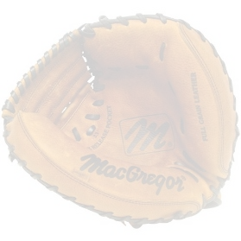

NOTES/OBJECTIVE:

OUT OF STRIKE ZONE

EDGE OF STRIKE ZONE